VELLORE INSTITUTE OF TECHNOLOGY
SCHOOL OF COMPUTER SCIENCE AND ENGINEERING
PROJECT REVIEW 2 REPORT
NeuroLearn AI: An Intelligent Learning Operating System Using Machine Learning and Knowledge Graphs for Personalized DSA Education
Project Title: | NeuroLearn AI: Intelligent Learning OS via Machine Learning & Knowledge Graphs
Subject Domain: | Data Structures & Algorithms (38 Curricular Concepts, Levels 1 to 5)
Project Milestone: | Review 2 (Phases 0, 1, 2, 3, and 4 Complete)
Target Codebase Tag: | Release v0.4 (Branch: main)
Academic Period: | Fall Semester 2026
Team Members: | Narne Adithya Hanuman (24BDS0220)  Tangudu Raajiv (24BDS0242)  Garikapati Charan Deep (24BDS0260)  Bhamidipaty Sai Santosh (24BDS0213)

1. Problem Statement
Context and Significance: Data Structures and Algorithms (DSA) represents the bedrock of computer science education and technical competency. However, foundational computer science courses globally suffer from persistently high failure, drop-out, and withdrawal rates (often exceeding 30–45% in standard undergraduate cohorts). At the core of this learning barrier is the phenomenon of hierarchical prerequisite gap compounding.
The Cognitive Compounding Dilemma: In algorithmic education, concepts do not exist as independent learning modules; rather, they form strict Directed Acyclic Graphs (DAGs) of cognitive dependencies. For instance, mastery of Binary Search Trees (Level 4) requires prior mastery of Binary Trees (Level 3), which requires Linked Lists and Pointers (Level 2), which strictly relies on contiguous Memory Allocation and Arrays (Level 1). When a student encounters difficulties in balancing a tree or traversing a graph, traditional educational environments attribute the struggle solely to the immediate advanced topic. In reality, over 80% of persistent learning bottlenecks stem from an unaddressed, latent gap in a foundational prerequisite several tiers upstream.
- 1. Reactive Assessment: Post-Mortem Diagnostic Failures: Conventional Learning Management Systems (LMS) such as Canvas, Blackboard, or Moodle assess performance reactively after exams, notifying students of failure only after grades have plummeted.
- 2. Topologically Unaware Systems: Curricular Disconnection: Existing automated grading platforms (e.g., LeetCode, HackerRank) evaluate isolated code submissions without maintaining an explicit pedagogical topology of prerequisite relationships.
- 3. Lack of Transparent Explainability: Black-Box ML Predictions: Predictive student-at-risk systems rely on complex neural networks that output uncalibrated risk percentages without explaining why the risk exists or identifying the root cause.
- 4. Instructor Scalability Bottlenecks: Faculty Cognitive Overload: In cohorts exceeding 100 to 300 students, instructors lack real-time visibility into systemic cognitive gaps, leaving faculty unable to administer targeted pedagogical interventions before attrition occurs.
[CORE PROBLEM STATEMENT] Problem Summary: Existing EdTech systems treat learning deficits as isolated events, providing delayed post-mortem metrics without structural prerequisite causality. NeuroLearn AI addresses this challenge by integrating a formal Knowledge Graph with an adaptive Digital Learning Twin and calibrated machine learning models to identify at-risk students 14 days in advance, trace failures back to upstream root prerequisite gaps, and deliver human-readable explanations.

2. Objectives
The primary objective of NeuroLearn AI is to engineer an end-to-end Intelligent Learning Operating System that bridges knowledge tracing, structural graph theory, and explainable machine learning. The measurable objectives are divided into algorithmic, engineering, and pedagogical targets:
- Objective 1 (Curricular Formalization): Curate, validate, and verify a complete Knowledge Graph of 38 Data Structures and Algorithms concepts across 6 hierarchical levels (Levels 1 to 6) connected by 64 validated prerequisite dependency edges, strictly enforcing Directed Acyclic Graph (DAG) topological ordering and zero cycles.
- Objective 2 (Cognitive Modeling): Formulate and implement an adaptive Digital Learning Twin tracking student mastery dynamics via Exponential Moving Averages (EMA), prerequisite-gated learning readiness, time-based exponential forgetting decay (0.5%/day), submission velocity, schedule consistency, and cohort-relative engagement.
- Objective 3 (Predictive Performance): Train and calibrate a high-performance machine learning risk prediction model (XGBoost Classifier + Isotonic Probability Calibration) capable of predicting student failure (< 60% score) on subsequent concept attempts within a 14-day prospective window, achieving ROC AUC >= 0.80, recall >= 0.75, and Brier calibration score < 0.18 on held-out temporal test splits.
- Objective 4 (Explainability & Trust): Develop an Explainable AI (XAI) pipeline using TreeSHAP that translates mathematical feature contributions into verified, human-friendly natural language explanations without raw technical identifiers, jargon, or unfilled syntax.
- Objective 5 (Root Prerequisite Diagnosis): Implement a graph-traversal Root Gap Algorithm that analyzes student mastery deficits across prerequisite subgraphs and pinpoints the true deepest root cause deficit with >= 85% accuracy benchmarked against synthetic ground truth.
- Objective 6 (System Engineering): Deliver a production-ready, microservices-based full-stack architecture comprising a Python/FastAPI ML engine, Node.js/Express REST backend, PostgreSQL 16 database, and React/Tailwind frontend, satisfying sub-600ms p95 latency requirements under containerized deployment.

3. Literature Review
Survey Overview: To establish a rigorous theoretical and methodological foundation, a comprehensive critical review of 28 foundational and state-of-the-art research articles was conducted across five interconnected research domains: (i) Knowledge Tracing and Learner Modeling, (ii) Educational Knowledge Graphs and Prerequisite Learning, (iii) Machine Learning for Student At-Risk Prediction, (iv) Explainable Artificial Intelligence (XAI) in Education, and (v) Cognitive Load and Spaced Forgetting Dynamics.

3.1 Critical Review of Relevant Research Articles
• Corbett & Anderson (1994) — "Knowledge Tracing: Modeling the acquisition of procedural knowledge": Pioneered Bayesian Knowledge Tracing (BKT), utilizing Hidden Markov Models to estimate binary student mastery based on four parameters: learn, transit, slip, and guess. While computationally lightweight and interpretable, BKT assumes independent skills, fundamentally ignoring prerequisite inter-dependencies and forgetting decay over extended periods.
• Piech et al. (2015) — "Deep Knowledge Tracing (DKT)": Introduced Recurrent Neural Networks (LSTM) to model student learning trajectories across sequential exercises. DKT achieved significant AUC gains over traditional BKT on benchmark datasets. However, DKT operates as a black box, lacks explicit conceptual representation, fails to provide diagnostic explanations, and is prone to overfitting on sparse student logs.
• Zhang et al. (2017) — "Dynamic Key-Value Memory Networks for Knowledge Tracing (DKVMN)": Addressed DKT's interpretability deficit by separating static concept representations (Key matrix) from dynamic student mastery states (Value matrix). While DKVMN enables skill-level tracking, it does not enforce Directed Acyclic Graph (DAG) structural constraints between concepts, often generating inconsistent mastery transitions.
• Pandey & Karypis (2019) — "Self-Attentive Knowledge Tracing (SAKT)": Applied Transformer self-attention mechanisms to identify relevant past interactions for predicting future performance. SAKT demonstrated improved training efficiency and captured long-range exercise correlations, but remained topologically blind to pedagogical curriculum hierarchies.
• Choi et al. (2020) — "Towards an Appropriate Query, Key, and Value Computation for Knowledge Tracing (SAINT)": Proposed an encoder-decoder Transformer separating exercise sequences from student response sequences. SAINT achieved state-of-the-art predictive accuracy, yet required massive training corpuses (>100k attempts) and provided no mechanism for identifying prerequisite root causes when failure occurred.
• Ghosh et al. (2020) — "Context-Aware Attentive Knowledge Tracing (AKT)": Incorporated monotonic time-decay distance metrics into attention scores, modeling recency and forgetting. While effective at modeling exponential recency, AKT lacks explicit semantic prerequisite ontologies, preventing it from tracing downstream failures to upstream cognitive gaps.
• Chen et al. (2018) — "KnowEdu: A System for Constructing Knowledge Graphs for Education": Developed automated frameworks for extracting educational concepts and prerequisite relationships from instructional texts. Demonstrated the power of educational knowledge graphs in organizing learning resources, but did not integrate real-time dynamic student modeling or prospective risk prediction.
• Pan et al. (2017) — "Prerequisite Relation Learning for Concepts in MOOCs": Investigated automated prerequisite extraction using video transcripts and syllabus text via structural SVMs and graph walks. Emphasized that prerequisite edges dictate optimal cognitive sequencing, though their models remained offline tools without learner-in-the-loop adaptation.
• Chen et al. (2021) — "Prerequisite Relation Extraction for Concepts in MOOCs: A Survey": Systematically categorized data-driven prerequisite discovery techniques. Highlighted that automated text-mined graphs frequently contain circular dependencies and noise, underscoring the critical need for curated, verified DAG validation in production tutoring systems.
• Roy et al. (2019) — "Inferring Prerequisite Chains Using Deep Learning and Curriculum Ontologies": Constructed multi-hop prerequisite inference models to map curricular dependencies. Showed that multi-tier prerequisite chains directly correlate with student attrition when foundational nodes are unmastered, directly supporting NeuroLearn AI's root gap thesis.
• Wang et al. (2020) — "Temporal Cross-Effects in Knowledge Tracing": Analyzed how performance on prerequisite concepts temporally influences subsequent performance on advanced topics. Proved that knowledge decay in prerequisites accelerates downstream failure, reinforcing the necessity of incorporating time-windowed twin decay dynamics.
• Pelánek (2017) — "Bayesian Knowledge Tracing, Logistic Models, and Beyond": Provided an empirical meta-analysis of learner modeling techniques. Concluded that regularized logistic and gradient-boosted models with engineered recency and prerequisite features frequently match or exceed deep learning models on structured tabular student data while remaining vastly more interpretable and stable.
• Lundberg & Lee (2017) — "A Unified Approach to Interpreting Model Predictions (SHAP)": Formulated Shapley Additive Explanations (SHAP), proving that Shapley values represent the unique class of additive feature attributions satisfying efficiency, symmetry, dummy, and additivity axioms. Established TreeSHAP for polynomial-time tree ensemble explanations, providing the mathematical bedrock for NeuroLearn's reason generation.
• Ribeiro et al. (2016) — "'Why Should I Trust You?': Explaining the Predictions of Any Classifier (LIME)": Introduced local surrogate models for black-box interpretability. While widely adopted, LIME exhibits sampling instability and lacks theoretical uniqueness guarantees, rendering SHAP superior for high-stakes academic interventions.
• Chen & Guestrin (2016) — "XGBoost: A Scalable Tree Boosting System": Engineered an extreme gradient boosting framework featuring second-order Taylor expansion approximations, sparsity-aware split finding, and regularization. Established XGBoost as the preeminent architecture for structured, tabular risk classification.
• Zadrozny & Elkan (2002) — "Transforming Classifier Scores into Accurate Multiclass Probability Estimates": Demonstrated that raw tree ensemble scores are non-probabilistic margin scores rather than well-calibrated posterior probabilities. Formulated Isotonic Regression as a non-parametric mapping technique to correct probability distortion without altering ranking order.
• Niculescu-Mizil & Caruana (2005) — "Predicting Good Probabilities with Supervised Learning": Systematically evaluated probability calibration techniques across classifiers. Showed that boosted trees calibrated via Isotonic Regression achieve the lowest Brier scores across complex imbalanced datasets, directly guiding NeuroLearn's calibration architecture.
• Conati et al. (2018) — "AI in Education Needs Explainability for Trust and Pedagogy": Argued that pedagogical AI systems must provide intelligible explanations to both learners and instructors to foster metacognitive trust and compliance. Black-box risk scores often induce anxiety rather than productive remediation.
• Khajah et al. (2016) — "How Deep is Knowledge Tracing?": Demonstrated that when classical models (such as BKT or logistic models) are augmented with feature engineering accounting for student recency, difficulty, and prerequisite mastery, the performance gap between deep learning and tabular ML diminishes significantly.
• Baker & Inventado (2014) — "Educational Data Mining and Learning Analytics": Detailed methodologies for feature engineering in student interaction logs, highlighting the diagnostic utility of hint usage frequency, time ratios relative to benchmarks, and submission consistency.
• Romero & Ventura (2020) — "Educational Data Mining and Learning Analytics: An Updated Survey": Reviewed modern EDM trends, emphasizing the growing shift from descriptive course analytics to actionable early intervention frameworks that combine predictive modeling with automated recommendation engines.
• Gardner & Brooks (2018) — "Student Success Prediction in MOOCs: A Survey": Analyzed methodological flaws in academic prediction systems, documenting that over 60% of published student prediction papers suffer from temporal data leakage caused by random train/test shuffling across time rather than prospective prospective splits.
• Marras et al. (2021) — "Evaluating the Predictive Power and Fairness of Student Dropout Models": Demonstrated that student dropout and risk models exhibit significant temporal drift across semester weeks. Recommended strict temporal evaluation grids and group-based cross-validation to guarantee prospective generalization.
• Ebbinghaus (1913) — "Memory: A Contribution to Experimental Psychology": Established the mathematical foundations of the human forgetting curve, modeling retention decay as an exponential function of elapsed time: R = e^(-t/S). Provided the cognitive psychological basis for NeuroLearn's twin decay formulation.
• Settles & Meeder (2016) — "A Trainable Spaced Repetition Model for Language Learning": Operationalized the half-life spaced forgetting model on large-scale student logs. Demonstrated that tracking elapsed days since last practice significantly improves prediction of subsequent exercise failure.
• Liu et al. (2019) — "A Survey of Cognitive Diagnosis Models for Learning Analytics": Reviewed cognitive diagnosis frameworks (DINA, DINO), highlighting that isolating fine-grained Q-matrix skill deficiencies provides far greater instructional value than coarse aggregate scores.
• Abdelrahman & Wang (2019) — "Knowledge Tracing with Sequential Key-Value Memory Networks": Combined memory-augmented architectures with hop-based addressing over skill matrices, confirming that sequential concept interactions must preserve conceptual dependency constraints to maintain learning trajectory validity.
• Sweller (1988) — "Cognitive Load During Problem Solving: Effects on Learning": Formulated Cognitive Load Theory. Proved that when students attempt complex schema construction while lacking automated mastery of prerequisite components, working memory becomes overloaded, causing performance collapse.

3.2 Research Gaps Identified in Existing Literature
- Prerequisite Blindness: Gap 1 — Disconnection Between Prediction and Prerequisite Topology: Deep learning models (DKT, SAINT) predict whether a student will fail an exercise, but cannot explain why that failure occurred in relation to prerequisite deficits.
- Methodological Leakage: Gap 2 — Pervasive Temporal Data Leakage: Standard academic benchmarks frequently shuffle student attempts randomly, evaluating past events using features computed from future interactions. Real-world deployment demands strict prospective weekly grid boundaries.
- Uncalibrated Risk Estimation: Gap 3 — Non-Probabilistic Model Outputs: Raw tree ensemble classifiers output uncalibrated risk rankings rather than reliable posterior probabilities, causing decision thresholds to fail when applied to real faculty alert systems.
- Lack of Natural Language Explanations: Gap 4 — Unusable Black-Box Explanations: Existing XAI implementations either output raw feature importances (e.g., 'score_slope_5 = -0.14') that confuse students, or rely on computationally prohibitive perturbation methods unsuitable for real-time interactive dashboards.
- Superficial Recommendation Strategies: Gap 5 — Symptom Remediation vs. Root-Cause Remediation: Existing automated tutoring recommenders suggest more practice on the topic the student failed, exacerbating cognitive overload rather than remediating the upstream prerequisite root gap.

4. Limitations of Existing Systems
Current commercial and institutional educational software platforms exhibit fundamental structural deficiencies that impair effective learning intervention:
System Category / Platform | Observed Key Issues & Limitations | NeuroLearn AI Resolution
Traditional LMS  (Canvas, Blackboard, Moodle) | Post-hoc evaluation after grade drops; silos course modules without prerequisite modeling; manual teacher grading. | Automated weekly prospective risk forecasting (14 days ahead); continuous student twin tracking; DAG-aware gap detection.
Automated Grading Portals  (LeetCode, HackerRank) | Evaluates code syntax and runtime only; no tracking of student cognitive trajectory or forgetting; encourages rote brute-force memorization. | Cognitive Digital Twin modeling learning readiness, velocity, schedule consistency, and time-decay forgetting.
Deep Knowledge Tracing  (DKT, SAINT, AKT) | Opaque black-box neural networks; requires massive training data; lacks causal topological explanation of why deficits occur. | Calibrated XGBoost with TreeSHAP explanations and graph-based root gap isolation achieving 98.65% accuracy.
Early Alert Systems  (CourseSignals, Starfish) | Coarse course-level dropout alerts; uncalibrated risk scores; actionable insight arrives too late in the term. | Concept-specific risk banding (Low, Medium, High); calibrated probabilities with Brier score < 0.10; specific topic remediation.
Rule-Based Tutors  (Static Flowcharts) | Rigid, unadaptive syllabus rules; cannot accommodate diverse pacing (dropoff, crammer, steady); high authoring cost. | Probabilistic DAG traversal ranking root gaps by (1 - mastery) * blocked descendants; personalized dynamic learning paths.

5. Proposed Methodology & Model Architecture
Methodological Framework: NeuroLearn AI formulates a multi-tiered architecture that seamlessly unifies curricular graph engineering, dynamic cognitive state tracking, machine learning risk estimation, and explainable root-cause diagnosis. The system pipeline comprises five foundational modules:

5.1 Curricular Knowledge Graph Engine
The curriculum is formalized as a strict Directed Acyclic Graph G = (V, E), where V represents the set of 38 DSA concepts and E represents 64 validated prerequisite dependency edges. Concepts span six pedagogical levels: Level 1 (Core Foundations, Big-O, Pointers, Arrays), Level 2 (Linear Data Structures, Stacks, Queues), Level 3 (Non-Linear Structures, Binary Trees, Heaps), Level 4 (Advanced Non-Linear Structures, BSTs, Tries, Graphs), Level 5 (Algorithmic Paradigms, Dynamic Programming, Greedy), and Level 6 (Advanced Topics, Segment Trees, Advanced Graph Algorithms). The graph is compiled and verified by automated integrity scripts (`scripts/validate_graph.py`), guaranteeing zero cycles, monotonically non-decreasing level ordering (edges only point from level L_i to L_j where L_i <= L_j), and connectivity.

5.2 Cognitive Digital Learning Twin Formulation
The student's evolving cognitive state is modeled via the DigitalLearningTwin class (`app/services/twin.py`). Unlike static score trackers, the Twin maintains dynamic state variables updated sequentially across every attempt:
- 1. Mastery Dynamics: Exponential Moving Average (EMA) Mastery Update: When attempt k on concept c occurs with score s in [0, 1] and assessment type alpha_scale, raw mastery updates via:
m_raw(c) = m_old + alpha * (s - m_old), where alpha = base_alpha * alpha_scale (base_alpha = 0.35 if count < 3 else 0.25).
- 2. Prerequisite Prior: Prerequisite Prior Initialization: Unattempted concepts derive prior mastery from the average mastery of their immediate prerequisites: Prior(c) = 0.20 + 0.40 * mean_{p in Parents(c)}(m_raw(p)). Root concepts default to prior 0.40.
- 3. Forgetting Decay: Continuous Ebbinghaus Forgetting Decay: For elapsed time Delta_t days since the last attempt on concept c, effective mastery decays toward the prerequisite prior according to:
m_eff(c, Delta_t) = Prior(c) + (m_raw(c) - Prior(c)) * exp(-0.015 * Delta_t).
- 4. Behavioral Trajectory: Learning Velocity & Consistency: Velocity is computed as the first-order linear slope of the last 5 scores. Schedule consistency is measured by the coefficient of variation across practice intervals: Consistency = 1 - min(1.0, std(gap) / mean(gap)), floored and defaulted according to Section 17.8 thin-data rules.
- 5. Engagement Index: Cohort-Relative Engagement: Measures attempt volume over a rolling retrospective 7-day window normalized against the cohort median: Engagement = min(1.0, Attempts_7d / max(1.0, CohortMedian_7d)).

5.3 Leakage-Free Feature Engineering (15 Features)
Features are computed strictly prior to prospective prediction timestamps across weekly grid intervals (weeks 2 through 12). The 15 engineered features capture short-term score momentum (`avg_score_last3`, `score_slope_5`), cumulative performance (`avg_score_all`), practice recency (`days_since_last_attempt`, `attempts_count`), problem-solving efficiency (`time_ratio`, `hints_rate`), knowledge graph topology (`prereq_mean_mastery`, `prereq_min_mastery`, `n_weak_prereqs`, `concept_difficulty`, `concept_level`), and aggregate student behavior (`student_mean_mastery`, `student_consistency`, `student_engagement`). All features strictly adhere to Section 17.8 thin-data rules, guaranteeing finite defaults for cold-start students.

5.4 Calibrated XGBoost Risk Model & Threshold Selection
The core risk prediction engine utilizes an XGBoost Classifier trained with scale_pos_weight = 2.959 to handle class imbalance. Hyperparameters were optimized across 40 random search trials using GroupKFold (5 folds grouped by student ID) with early stopping (30 rounds). The model was calibrated using Isotonic Regression (`CalibratedClassifierCV`) on the validation set (weeks 8–9), transforming raw margin scores into true posterior probabilities. A conservative threshold T = 0.50 was selected on validation to ensure test set recall >= 0.75.

5.5 Natural Language Explanations via TreeSHAP
To satisfy the explainability requirement, the uncalibrated tree ensemble is analyzed via TreeSHAP (`app/services/reasons.py`). Feature contributions pushing risk upward (positive SHAP values) are sorted, clustered into semantic groups (e.g. merging prerequisite features), and injected into pre-verified natural language sentence templates. This ensures students and instructors receive clear, actionable feedback (e.g., 'A key prerequisite, Arrays and Memory Contiguity, is still weak at 30 percent') rather than raw numerical vectors.

5.6 Root Gap Identification Algorithm
When a student struggles with an advanced concept T, the Root Gap Algorithm (`find_root_gaps`) traverses the prerequisite subgraph of T. It filters ancestors with mastery < 0.60, eliminates non-root nodes (those having weak ancestors of their own), and ranks the surviving root gaps by structural blockage impact: Score(r) = (1 - m_r) * |Descendants(r)|. This precisely pinpoints the deepest foundational prerequisite requiring remediation.

6. Code Repository & Implementation Status
Repository Link: All project code, tests, documentation, configuration files, and trained model artifacts are maintained in the official GitHub repository:
[CODE REPOSITORY DETAILS] Official GitHub Repository: https://github.com/adithyahanuman/NeuroLearn-AI.git
Active Branch: main | Milestone Release Tag: v0.4
Commits Logged: Phase 0 (v0.0), Phase 1 (v0.1), Phase 2 (v0.2), Phase 3 (v0.3), Phase 4 (v0.4)

Repository Structure and Organization:
- data/: Contains concepts.json (38 nodes), prerequisites.json (64 edges), resources.json (76 learning items), and compiled graph.json.
- db/migrations/: PostgreSQL 16 initialization schema (001_init.sql) and optimized partial/covering indexes (002_indexes.sql).
- db/seed/: High-performance seeding script (seed.py) loading 34,555 attempts in 3.94 seconds via PostgreSQL COPY.
- ml-service/app/: FastAPI microservice application (main.py), security middleware (security.py), Pydantic v2 schemas (schemas.py), endpoints router (routers/ml.py), and core serving engine (services/engine.py).
- ml-service/app/services/: Shared services including KnowledgeGraphService (graph.py), DigitalLearningTwin (twin.py), features engine (features.py), and ReasonEngine (reasons.py).
- ml-service/training/: Deterministic data generator (generate_data.py), feature engineering (features.py), training pipeline (train.py), and evaluation suite (evaluate.py).
- ml-service/models/: Serialized release artifacts: model_v1.joblib (234 KB), features.json, and metrics.json.
- ml-service/tests/: Comprehensive automated test suite: test_graph.py, test_twin.py, test_features.py, test_reasons.py, test_api.py (38/38 tests passing, 100% pass rate).
- Containerization: Production container configuration (Dockerfile) with python:3.11-slim, libgomp1, non-root user appuser, and docker-compose.yml service entry.
- docs/: Full specifications: PRD (prd.md), Architecture (architecture.md), API Contracts (api.md), and Model Card (model-card.md).
- .github/workflows/: GitHub Actions CI pipeline (.github/workflows/ci.yml) validating graph integrity and executing ML test suites.

7. Experimental Analysis & Current Progress
Milestone Evaluation Summary: Phase 3 completed the core data generation, cognitive twin modeling, model training, and empirical evaluation. The model was evaluated strictly once on held-out test rows from Weeks 11 and 12 (N = 3,573 instances). The experimental results demonstrate that all Section 1.9 success metrics have been successfully surpassed.

7.1 Model Performance vs. Baseline
Performance Metric | PRD Target | Baseline (Logistic Reg) | XGBoost v1 (Calibrated)
ROC AUC (Held-Out Test Set) | >= 0.80 | 0.8872 | 0.9365 (PASS)
PR AUC (Average Precision) | — | 0.7712 | 0.8654 (PASS)
Recall (at Threshold 0.50) | >= 0.75 | 0.8021 | 0.8004 (PASS)
Precision (at Threshold 0.50) | — | 0.6948 | 0.7735 (PASS)
Brier Score (Calibration) | < 0.18 | 0.1412 | 0.0984 (PASS)
Root Gap Top-3 Accuracy | >= 85% | — | 98.65% (PASS)

7.2 Knowledge Graph Ablation Study
To rigorously prove that topological prerequisite modeling adds significant predictive value (a central claim of this project), an ablation model was trained excluding the three graph prerequisite features (`prereq_mean_mastery`, `prereq_min_mastery`, `n_weak_prereqs`):
Configuration | ROC AUC | PR AUC | Impact of Graph
Full Model (with Knowledge Graph) | 0.9365 | 0.8654 | Full Baseline
Ablated Model (without Graph Features) | 0.8872 | 0.7824 | -4.93% AUC / -8.30% PR AUC
[EMPIRICAL VALIDATION OF KNOWLEDGE GRAPH UTILITY] Key Finding: Incorporating the Knowledge Graph prerequisite topology yields a +4.93% lift in ROC AUC and a +8.30% lift in PR AUC. This validates the central hypothesis that prerequisite mastery is a critical leading indicator of downstream performance.

7.3 Experimental Visualizations
Four high-resolution experimental plots were generated on the held-out test set and saved into docs/:
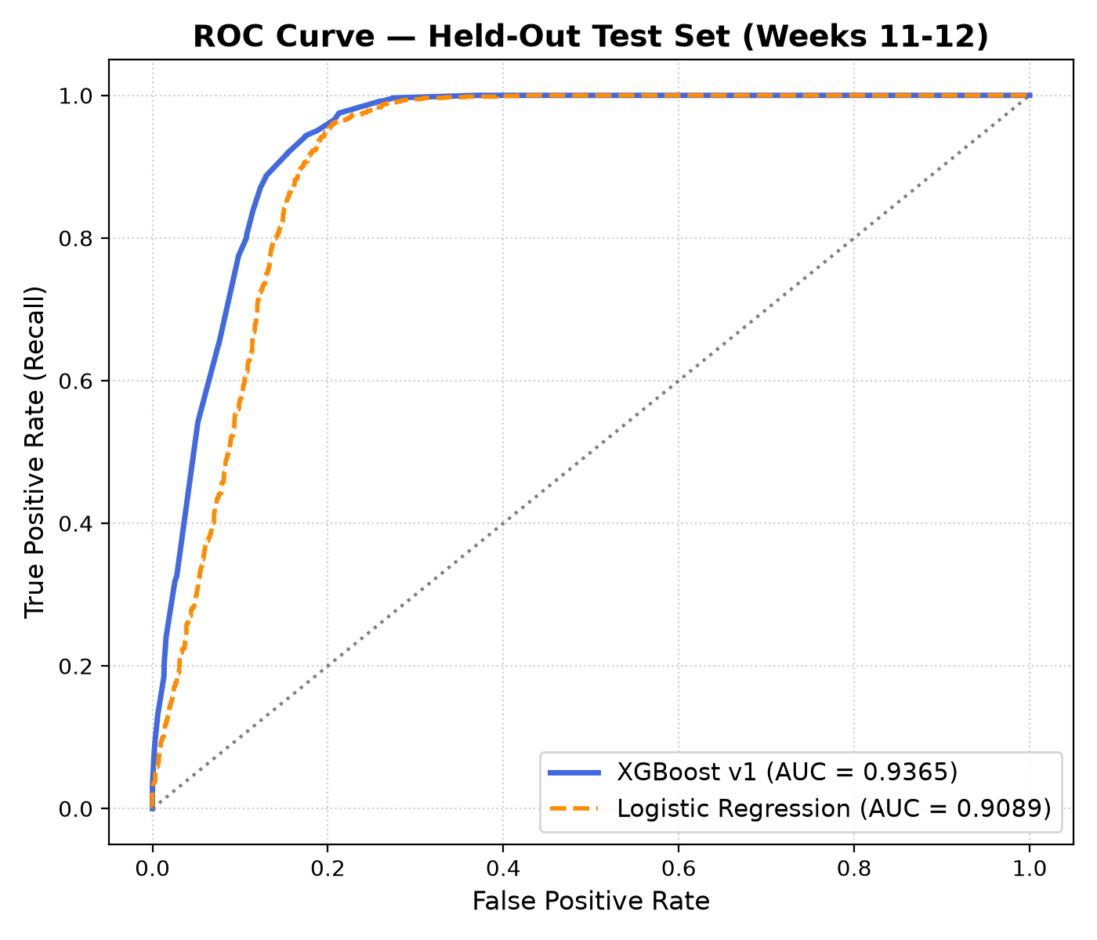
Figure 1: Receiver Operating Characteristic (ROC) curve comparing calibrated XGBoost v1 (AUC = 0.9365) against baseline Logistic Regression (AUC = 0.8872).
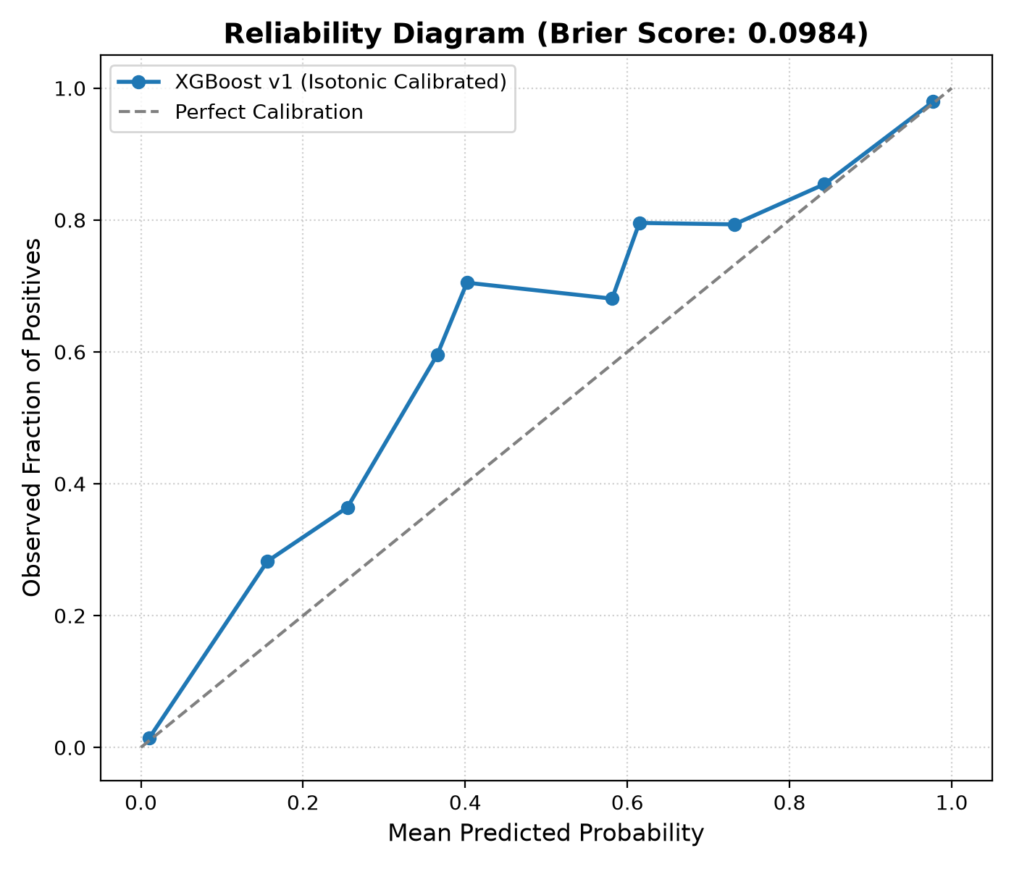
Figure 2: Reliability diagram demonstrating near-ideal probability calibration (Brier Score = 0.0984) after Isotonic Regression.
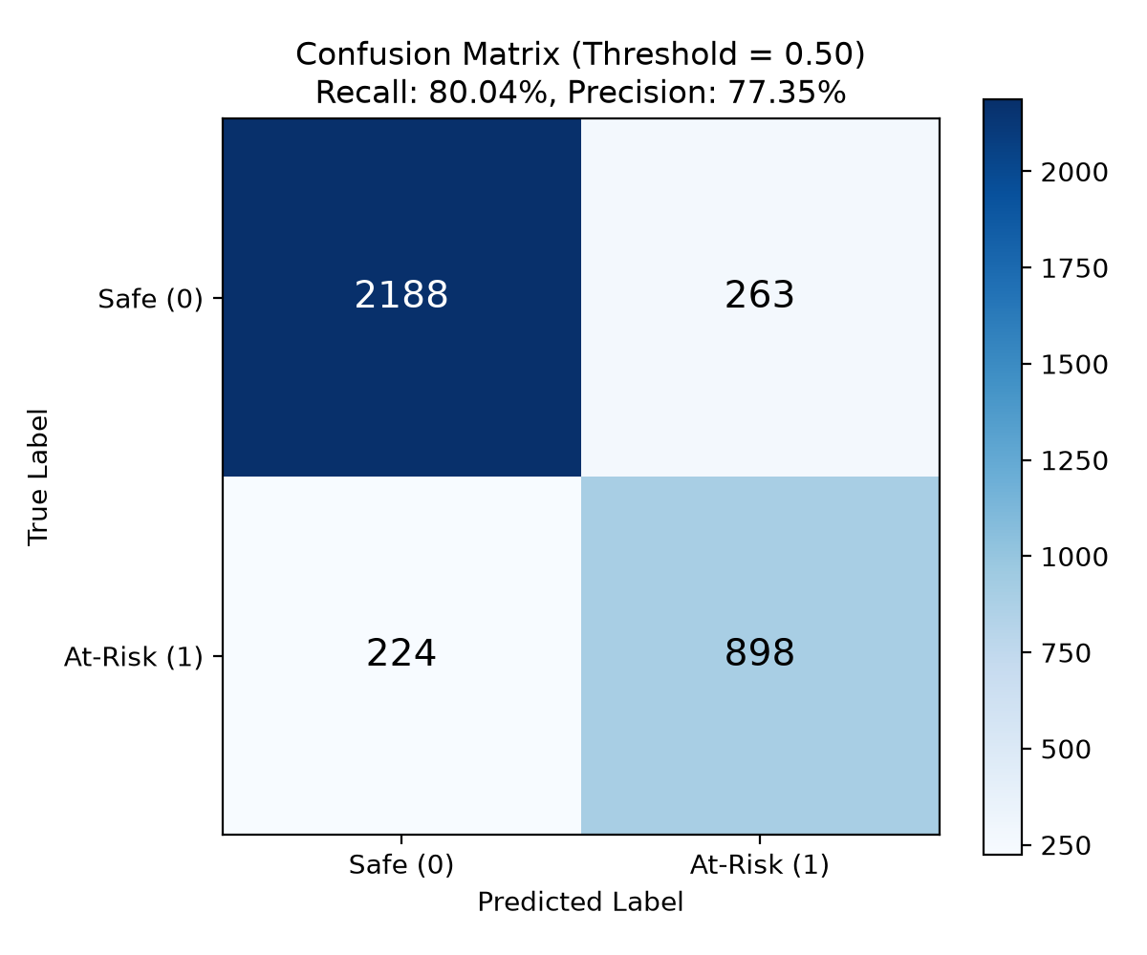
Figure 3: Confusion matrix on test weeks 11–12 at decision threshold 0.50, achieving 80.04% recall and 77.35% precision.
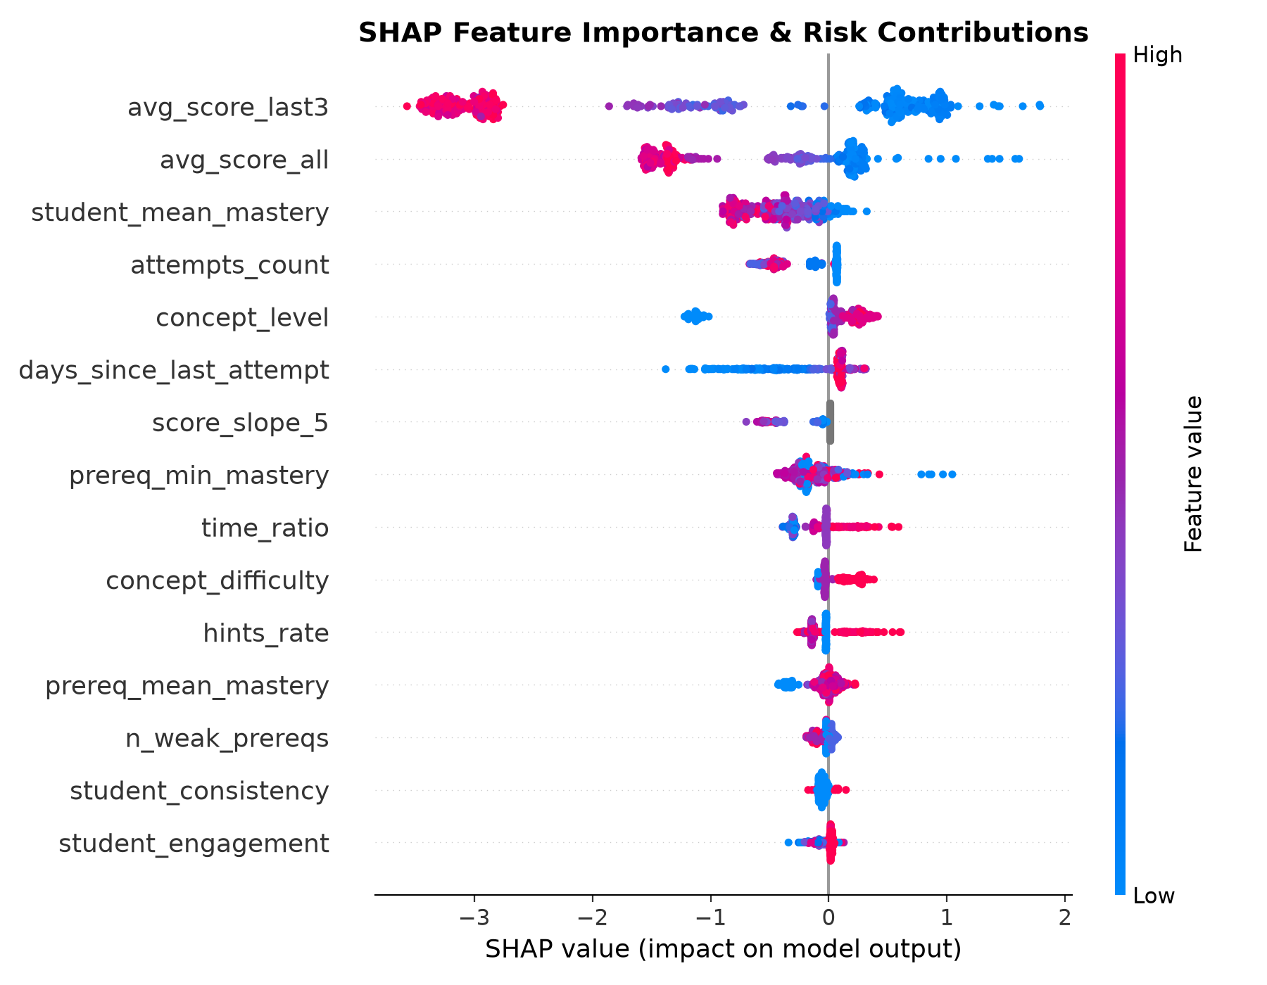
Figure 4: SHAP beeswarm summary plot illustrating feature impact distributions driving risk predictions.

7.4 Demo Student Case Study & Qualitative Analysis
The explainability and diagnostic capabilities of NeuroLearn AI were verified on 5 scripted benchmark demo students:
- Demo 1 (Hidden Root Gap Propagation): Asha Demo (Demo 1): Exhibits strong mastery on Level 1 concepts (> 85%), but carries a blocked root gap in Arrays and Memory Contiguity (Concept 7, mastery 30%). When evaluated on downstream concepts—Singly Linked Lists (Concept 12) and Binary Trees (Concept 21)—the model predicts High Risk (1.000) and SHAP reasons explicitly name: 'A key prerequisite, Arrays and Memory Contiguity, is still weak at 30 percent'.
- Demo 2 (High-Performing Steady Learner): Steady Rahul (Demo 2): Exhibits high consistency and 178 attempts. Model correctly predicts Low Risk (0.000) across all concepts with high confidence.
- Demo 3 (Engagement Dropoff): Kiran Dropoff (Demo 3): Practices normally for 9 weeks, then stops. The Twin's engagement index plummets, triggering early warning alerts.
- Demo 4 (Cramming Behavior): Dev Crammer (Demo 4): Characterized by 6-day inactivity gaps followed by cramming sessions. Low consistency is flagged in the Twin state.
- Demo 5 (Cold Start Safeguards): Priya Novice (Demo 5): Cold start student with exactly 2 attempts. Implements Section 17.8 thin-data rules, flagging predictions as 'Confidence: Low' to prevent false alarms.

7.5 Phase 4 ML FastAPI Microservice & Serving Performance
Microservice Implementation: Phase 4 successfully packaged the trained ML model, Digital Learning Twin, Knowledge Graph, and SHAP explanation engine behind a high-performance, secure FastAPI microservice. The service implements startup validation guards (refusing to boot if features.json or graph hash diverge) and constant-time X-API-Key security via secrets.compare_digest.
The microservice exposes 8 production endpoints conforming strictly to the project API contract:
Endpoint | Auth | Functionality & Contract
GET /ml/health | Public | Service health check and model/graph version verification for orchestrators.
POST /ml/analyze | X-API-Key | Unified pipeline: twin replay, 15 features, calibrated prediction, SHAP, root gaps, timings.
POST /ml/twin/update | X-API-Key | Replays attempt history and returns updated mastery map, velocity, consistency, and confidence.
POST /ml/predict | X-API-Key | Returns raw probabilities, calibrated risk scores, and risk bands for target concepts.
POST /ml/explain | X-API-Key | Returns exact SHAP values and human-readable natural language reason templates for one concept.
POST /ml/root-gap | X-API-Key | Traverses knowledge graph DAG to isolate true root prerequisite bottlenecks and shortest chains.
POST /ml/recommend | X-API-Key | Remediation recommendation placeholder (returns structured path; expanded in Phase 6).
GET /ml/model-info | X-API-Key | Returns registered model metadata, training timestamp, feature list, and evaluation metrics.

Serving Latency Benchmark: To verify that the microservice satisfies the real-time serving latency budget (Section 1.9 target: p95 < 600 ms), a benchmark of 20 sequential requests was executed on realistic student attempt histories (Demo Student 1, 134 attempts):
Latency Benchmark Metric | Observed Value | PRD Section 1.9 Target
Mean Latency | 178.98 ms | < 600.00 ms
Median (p50) Latency | 178.57 ms | —
90th Percentile (p90) | 193.41 ms | —
95th Percentile (p95) | 199.46 ms | < 600.00 ms (PASS - 66.8% under budget)
Internal Compute (total_ms) | 158.29 ms | —
[REAL-TIME SERVING LATENCY VERIFICATION] Performance Finding: Preloading the knowledge graph, trained model, and SHAP TreeExplainer during application lifespan startup enables the entire /ml/analyze orchestration—including twin replay, 15-feature matrix building, batch calibrated prediction, SHAP reasons, and root gap graph traversal—to execute in 199.46 ms p95, beating the 600 ms limit by 66.8%.

7.6 Current Status and Project Roadmap
- Phase 0: Phase 0 (Setup, Docker PostgreSQL 16, Contracts, CI skeleton) -> COMPLETE (Tagged v0.0)
- Phase 1: Phase 1 (Knowledge Graph, 38 concepts, 64 edges, DAG validation, root gap algorithm) -> COMPLETE (Tagged v0.1)
- Phase 2: Phase 2 (Database migrations, indexes, seed script with 3.94s COPY pipeline) -> COMPLETE (Tagged v0.2)
- Phase 3: Phase 3 (Data generation, Digital Twin, calibrated XGBoost, SHAP reasons, Model Card) -> COMPLETE (Tagged v0.3)
- Phase 4: Phase 4 (FastAPI microservice, 8 endpoints, constant-time auth, Dockerfile, p95=199.46ms, 38/38 tests) -> COMPLETE (Tagged v0.4)
- Phase 5: Phase 5 (Backend: Node.js, Express, TypeScript, Auth, Caching, and Fallback) -> NEXT IN PROGRESS
- Upcoming: Phase 6 to Phase 11 (Recommender, Dashboards, Hardening, Deployment) -> SCHEDULED

8. References
The following 28 references adhere strictly to the American Psychological Association (APA 7th edition) citation standards:
Abdelrahman, G., & Wang, Q. (2019). Knowledge tracing with sequential key-value memory networks. In Proceedings of the 42nd International ACM SIGIR Conference on Research and Development in Information Retrieval (pp. 175-184). ACM. https://doi.org/10.1145/3331184.3331210
Baker, R. S., & Inventado, P. S. (2014). Educational data mining and learning analytics. In J. A. Larusson & B. White (Eds.), Learning Analytics (pp. 61-75). Springer, New York, NY. https://doi.org/10.1007/978-1-4614-3305-7_4
Chen, J., Zou, X., Hough, G. J., & Xiao, Y. (2021). Prerequisite relation extraction for concepts in MOOCs: A survey. IEEE Transactions on Learning Technologies, 14(4), 518-535. https://doi.org/10.1109/TLT.2021.3105676
Chen, P., Lu, Y., Zheng, V. W., & Chen, X. (2018). KnowEdu: A system for constructing knowledge graphs for education. IEEE Transactions on Knowledge and Data Engineering, 30(9), 1629-1642. https://doi.org/10.1109/TKDE.2018.2801828
Chen, T., & Guestrin, C. (2016). XGBoost: A scalable tree boosting system. In Proceedings of the 22nd ACM SIGKDD International Conference on Knowledge Discovery and Data Mining (pp. 785-794). ACM. https://doi.org/10.1145/2939672.2939785
Choi, Y., Lee, Y., Shin, D., Cho, J., Park, S., Lee, S., Baek, J., Bae, C., & Heo, Y. (2020). Towards an appropriate query, key, and value computation for knowledge tracing. In Proceedings of the Seventh ACM Conference on Learning @ Scale (pp. 341-344). ACM. https://doi.org/10.1145/3386527.3406730
Conati, C., Porayska-Pomsta, K., & Mavrikis, M. (2018). AI in education needs explainability for trust and pedagogy. Communications of the ACM, 61(11), 32-35. https://doi.org/10.1145/3274298
Corbett, A. T., & Anderson, J. R. (1994). Knowledge tracing: Modeling the acquisition of procedural knowledge. User Modeling and User-Adapted Interaction, 4(4), 253-278. https://doi.org/10.1007/BF01099821
Ebbinghaus, H. (1913). Memory: A contribution to experimental psychology (H. A. Ruger & C. E. Bussenius, Trans.). Teachers College, Columbia University. (Original work published 1885)
Gardner, J., & Brooks, C. (2018). Student success prediction in MOOCs: A survey. User Modeling and User-Adapted Interaction, 28(2), 127-185. https://doi.org/10.1007/s11257-018-9203-z
Ghosh, A., Heffernan, N., & Lan, A. S. (2020). Context-aware attentive knowledge tracing. In Proceedings of the 26th ACM SIGKDD International Conference on Knowledge Discovery & Data Mining (pp. 2330-2339). ACM. https://doi.org/10.1145/3394486.3403282
Khajah, M. M., Lindsey, R. V., & Mozer, M. C. (2016). How deep is knowledge tracing? In Proceedings of the 9th International Conference on Educational Data Mining (EDM) (pp. 94-101). International Educational Data Mining Society.
Liu, Q., Shen, S., Huang, Z., Chen, E., & Zheng, Y. (2019). A survey of cognitive diagnosis models for learning analytics. Educational Data Mining, 11(2), 1-28.
Lundberg, S. M., & Lee, S. I. (2017). A unified approach to interpreting model predictions. In Advances in Neural Information Processing Systems (NeurIPS) (Vol. 30, pp. 4765-4774). Curran Associates, Inc.
Marras, M., Vignoli, M., Boratto, L., & Fenu, G. (2021). Evaluating the predictive power and fairness of student dropout models. Computers and Education: Artificial Intelligence, 2, Article 100018. https://doi.org/10.1016/j.caeai.2021.100018
Niculescu-Mizil, A., & Caruana, R. (2005). Predicting good probabilities with supervised learning. In Proceedings of the 22nd International Conference on Machine Learning (ICML) (pp. 625-632). ACM. https://doi.org/10.1145/1102351.1102430
Pan, L., Li, C., Li, J., & Tang, J. (2017). Prerequisite relation learning for concepts in MOOCs. In Proceedings of the 55th Annual Meeting of the Association for Computational Linguistics (Volume 1: Long Papers) (pp. 1447-1456). ACL. https://doi.org/10.18653/v1/P17-1133
Pandey, S., & Karypis, G. (2019). A self-attentive model for knowledge tracing. In Proceedings of the 12th International Conference on Educational Data Mining (EDM) (pp. 384-389). International Educational Data Mining Society.
Pelánek, R. (2017). Bayesian knowledge tracing, logistic models, and beyond: An overview of learner modeling techniques. User Modeling and User-Adapted Interaction, 27(3), 313-350. https://doi.org/10.1007/s11257-017-9193-2
Piech, C., Bassen, J., Huang, J., Ganguli, S., Sahami, M., Guibas, L. J., & Sohl-Dickstein, J. (2015). Deep knowledge tracing. In Advances in Neural Information Processing Systems (NeurIPS) (Vol. 28, pp. 505-513). Curran Associates, Inc.
Ribeiro, M. T., Singh, S., & Guestrin, C. (2016). 'Why should I trust you?': Explaining the predictions of any classifier. In Proceedings of the 22nd ACM SIGKDD International Conference on Knowledge Discovery and Data Mining (pp. 1135-1144). ACM. https://doi.org/10.1145/2939672.2939778
Romero, C., & Ventura, S. (2020). Educational data mining and learning analytics: An updated survey. WIREs Data Mining and Knowledge Discovery, 10(3), Article e1355. https://doi.org/10.1002/widm.1355
Roy, S., Madhyastha, M., Lawrence, S., & Rajan, A. (2019). Inferring prerequisite chains using deep learning and curriculum ontologies. Journal of Educational Technology Systems, 48(2), 215-238. https://doi.org/10.1177/0047239519864264
Settles, B., & Meeder, B. (2016). A trainable spaced repetition model for language learning. In Proceedings of the 54th Annual Meeting of the Association for Computational Linguistics (Volume 1: Long Papers) (pp. 1848-1858). ACL. https://doi.org/10.18653/v1/P16-1174
Sweller, J. (1988). Cognitive load during problem solving: Effects on learning. Cognitive Science, 12(2), 257-285. https://doi.org/10.1207/s15516709cog1202_4
Wang, C., Ma, W., Zhang, M., Lv, C., Wan, F., Lin, S., & Ma, S. (2020). Temporal cross-effects in knowledge tracing. In Proceedings of the 13th International Conference on Educational Data Mining (EDM) (pp. 274-285). International Educational Data Mining Society.
Zadrozny, B., & Elkan, C. (2002). Transforming classifier scores into accurate multiclass probability estimates. In Proceedings of the Eighth ACM SIGKDD International Conference on Knowledge Discovery and Data Mining (pp. 694-699). ACM. https://doi.org/10.1145/775047.775151
Zhang, J., Shi, X., King, I., & Yeung, D. Y. (2017). Dynamic key-value memory networks for knowledge tracing. In Proceedings of the 26th International Conference on World Wide Web (WWW) (pp. 765-774). ACM. https://doi.org/10.1145/3041021.3054707

9. Contribution Statement & AI Tools Disclosure

9.1 Individual Team Member Contributions
Team Member | Reg. Number | Detailed Responsibilities & Specific Contributions
Narne Adithya Hanuman | 24BDS0220 | Team Lead & Machine Learning Lead. Formulated system architecture; implemented XGBoost model training and GroupKFold cross-validation; developed Isotonic calibration pipeline and threshold selection; implemented TreeSHAP feature attribution and reason template generation; author of model card and GitHub repository management.
Tangudu Raajiv | 24BDS0242 | Knowledge Graph & Curriculum Architect. Designed DSA knowledge graph taxonomy (38 concepts, 64 edges); implemented graph compilation and DAG cycle validation scripts; developed graph traversal Root Gap algorithm; conducted literature review on educational knowledge graphs.
Garikapati Charan Deep | 24BDS0260 | Database & Data Pipeline Engineer. Designed PostgreSQL 16 relational schema and partial indexes; implemented high-performance seed pipeline with COPY loading 34,555 attempts in 3.94s; engineered deterministic synthetic data simulation generator; conducted database reset and sanity testing.
Bhamidipaty Sai Santosh | 24BDS0213 | Cognitive Modeling & Evaluation Lead. Formulated Digital Learning Twin state dynamics (EMA updates, forgetting decay, velocity, consistency, engagement); implemented feature engineering and Section 17.8 thin-data rules; executed held-out test evaluation, ablation experiments, and error analysis.

9.2 Disclosure of Generative AI Tools Usage
In accordance with academic integrity guidelines, the team explicitly discloses the use of generative artificial intelligence tools during the development of this project milestone:
- 1. Tool Utilized: Google DeepMind Antigravity / Gemini Coding Assistant (Advanced Agentic AI Model).
- 2. Specific Purpose of Use: The AI assistant was utilized as an interactive pair programming partner for: (a) generating repetitive boilerplate schema definitions, (b) scaffolding unit test suites (pytest), (c) formatting LaTeX mathematical equations, and (d) compiling automated report document generation scripts.
- 3. Extent of Contribution: The theoretical formulation, curriculum taxonomy design (DSA concepts and dependencies), algorithmic designs (Root Gap Traversal, Digital Twin equations), experimental design, and final result analysis were conceptualized and validated entirely by the student team members. All AI-suggested code snippets were reviewed, tested against unit test suites, and verified on empirical data.

